### PRODUCT

A **product** is an object or system made available for consumer use; it is anything that can be offered to a market to satisfy the desire or need of a customer.

### SOFTWARE

1. Software is a set of instructions or programs instructing a computer to do specific tasks. Software is a generic term used to describe computer programs. Scripts, applications, programs and a set of instructions are all terms often used to describe software.
2. In simple,software is a collection of instructions that enable the user to interact with a computer, its hardware, or perform tasks. Without software, computers would be useless.
3. Software is also a product

Eg: Windows, MacOS, Linux - Operating Systems.

Windows Media Player, iTunes, VLC media player - Playing rich media.

Avast, Kaspersky, Quickheal - Antivirus.

### DESKTOP APPLICATIONS

A desktop application is an application which runs on only one machine and usually does not require connectivity to some server. An example would be the Microsoft Office programs, like Word, Excel, and so on.

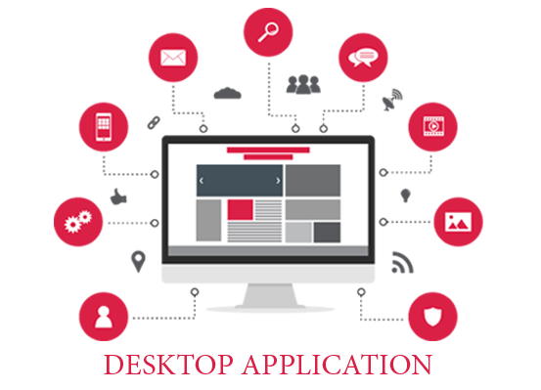

### WEB APPLICATIONS

A Web application (Web app) is an application program that is stored on a remote server and delivered over the Internet through a browser interface. Web services are Web apps by definition and many, although not all, websites contain Web apps.

Eg:Web applications include online forms, shopping carts, word processors, spreadsheets, video ,photo editing and email programs such as Gmail, Yahoo and AOL. Popular applications include Google Apps and Microsoft 365.

### DIFF BETWEEN DESKTOP AND WEB APPLICATION

A desktop application is an application which runs within your system over the operating system. It usually uses the resources from your own computer. It may or may not require a network connection to work. A web application generally runs inside a web browser.

### MOBILE APPLICATION

A mobile app is a software application developed specifically for **use** on small, wireless computing devices, such as smart phones and tablets, rather than desktop or laptop computers.

Mobile applications frequently serve to provide users with similar services to those accessed on PCs.

